Visual Designs: https://www.figma.com/design/i6Aem1zrdjKtyQm8x12hjZ/Untitled?node-id=0-1&t=3E5R1LOWqhvmTqAb-1
(If for any reason this link does not work, please contact my college for a working link. If for some reason this is not possible, please refer to the visual designs document with the images note these may be harder to read Thank you.)
Contents
Site Map 1
Database Design 3
Data Dictionary 3
AspNetUsers 3
AspNetUserTokens 4
AspNetUserClaims 5
AspNetUserRoles 5
AspNetUserLogins 5
AspNetRoles 6
AspNetRoleClaims 6
Producers 6
Items 7
ShoppingCart 8
CartItems 8
Orders 8
OrderItems 9
Algorithm Designs (Flowcharts): 10
Login Flowchart 10
Register Flowchart 11
Placing an order Flowchart 12
Producer Managing Stock Flowchart 13
Updating Account Details Flowchart 15
Test Strategy 16

Site Map:
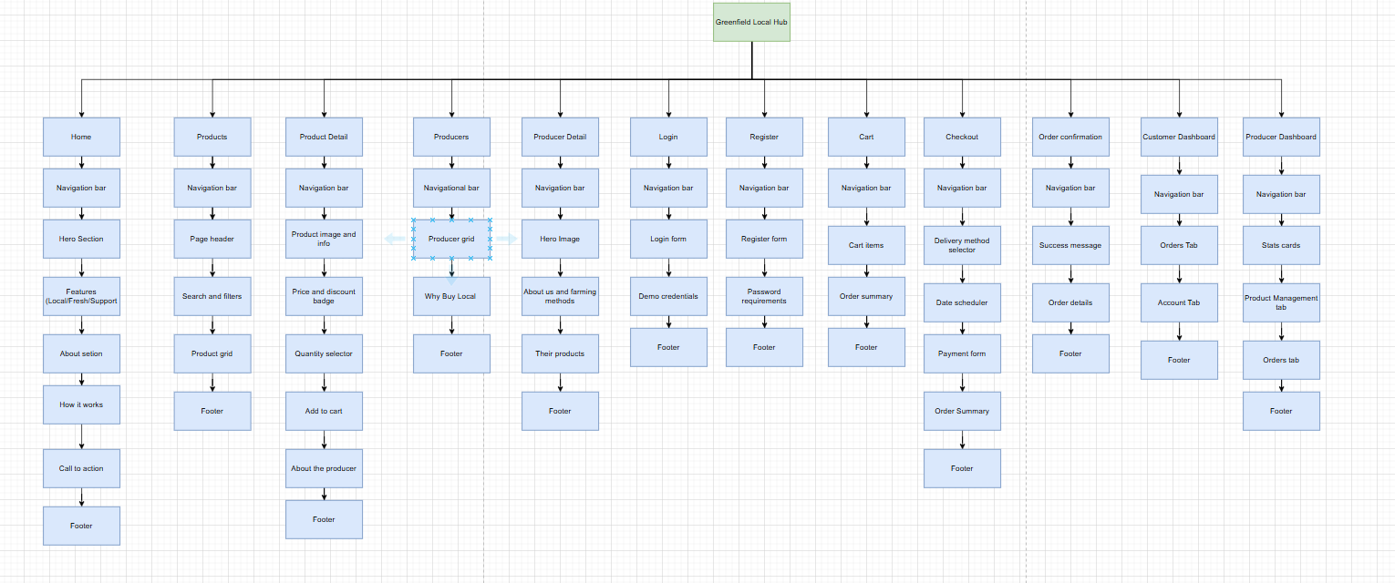

Database Design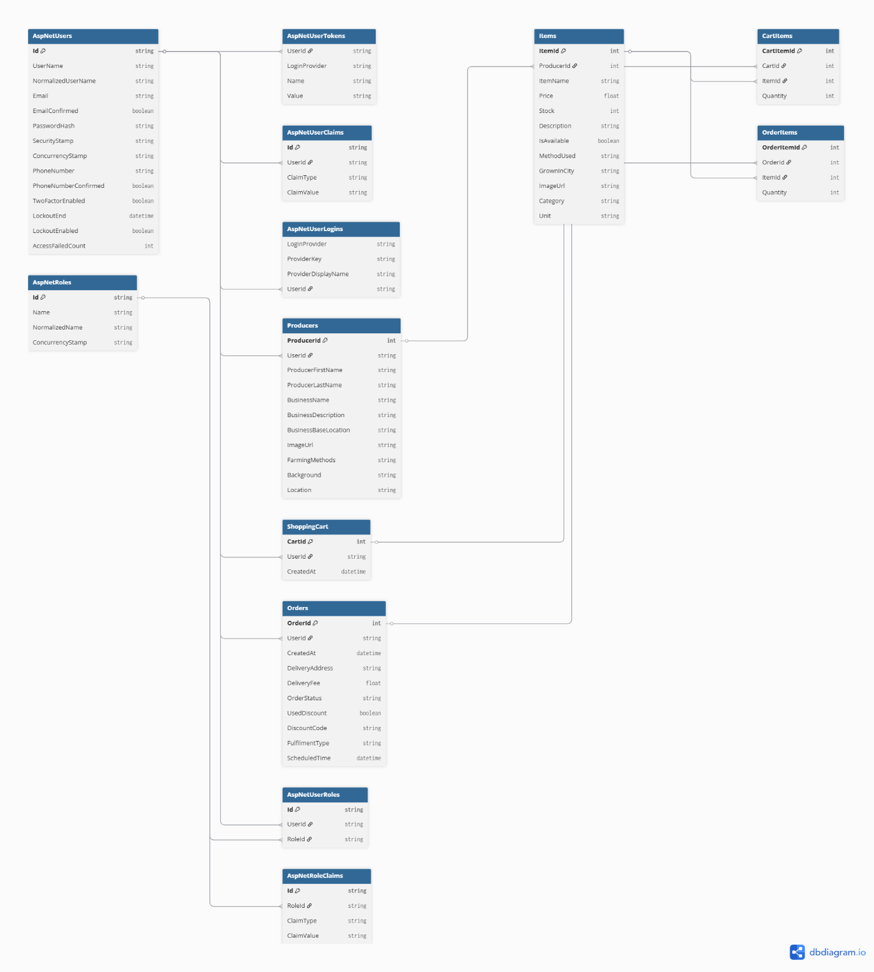

Data Dictionary

AspNetUsers
Column | Data Type | Required | Default | Validation | Primary/Foreign
Id | string | Yes | Autogenerated | Max 256 characters | Primary
UserName | String | Yes |  | Uppercase of username
NormalizedUserName | String | Yes |  | Must be valid email format
Email | String | Yes
EmailConfirmed | Boolean | Yes | false | Min 8 characters, must contain letter, number and special character
PasswordHash | String | Yes |  | Auto generated
SecurityStamp | String | Yes |  | Auto generated
ConcurrencyStamp | String | Yes |  | Must contain valid numeric digits in correct format
PhoneNumber | string | No
PhonenumberConfirmed | Boolean | Yes | False
TwoFactorEnabled | Boolean | Yes | False
LockoutEnd | Datetime | No
LockoutEnabled | Boolean | Yes | False
AccessFailedCount | int | yes | 0

AspNetUserTokens
Column | Data Type | Required | Default | Validation | Primary/Foreign
UserId | String | Yes |  | Must exist in AspNetUsers | Foreign
LoginProvider | String | Yes
Name | String | Yes
Value | String | No

AspNetUserClaims
Column | Data Type | Required | Default | Validation | Primary/Foreign
Id | String | Yes | Auto-generated |  | Primary
UserId | String | Yes |  | Must exist in AspNetUsers | Foreign
ClaimType | String | No
ClaimValue | String | No

AspNetUserRoles
Column | Data Type | Required | Default | Validation | Primary/Foreign
Id | String | Yes | Auto-generated |  | Primary
UserId | String | Yes |  | Must exist in AspNetUsers | Foreign
RoleId | String | Yes |  | Must exist in AspNetRoles | Foreign

AspNetUserLogins
Column | Data Type | Required | Default | Validation | Primary/Foreign
LoginProvider | String | Yes |  |  | Primary
ProviderKey | String | Yes
ProviderDisplayName | String | No
UserId | String | Yes |  | Must exist in AspNetUsers | Foreign

AspNetRoles
Column | Data Type | Required | Default | Validation | Primary/Foreign
Id | String | Yes | Auto-generated GUID |  | Primary
Name | String | Yes
NormalizedName | String | Yes |  | Uppercase of Name
ConcurrencyStamp | String | No | Auto-generated

AspNetRoleClaims
Column | Data Type | Required | Default | Validation | Primary/Foreign
Id | String | Yes | Auto-generated |  | Primary
RoleId | String | Yes |  | Must exist in AspNetRoles | Foreign
ClaimType | String | No
ClaimValue | String | No

Producers
Column | Data Type | Required | Default | Validation | Primary/Foreign
ProducerId | Int | Yes | Auto-incremented |  | Primary
UserId | String | Yes |  | Must exist in AspNetUsers | Foreign
ProducerFirstName | String | Yes |  | Max 100 characters
ProducerLastName | String | Yes |  | Max 100 characters
BusinessName | String | Yes |  | Max 150 characters
BusinessDescription | String | No |  | Max 1000 characters
BusinessBaseLocation | String | No |  | Max 200 characters
ImageUrl | String | No |  | Must be valid URL format
FarmingMethods | String | No |  | Max 2000 characters
Background | String | No |  | Max 2000 characters
Location | String | No |  | Max 200 characters

Items
Column | Data Type | Required | Default | Validation | Primary/Foreign
ItemId | Int | Yes | Auto-incremented |  | Primary
ProducerId | Int | Yes |  | Must exist in Producers | Foreign
ItemName | String | Yes |  | Max 150 characters
Price | Float | Yes |  | Must be greater than 0
Stock | Int | Yes | 0 | Must be 0 or greater
Description | String | No |  | Max 1000 characters
IsAvailable | Boolean | Yes | true
MethodUsed | String | No |  | Max 500 characters
GrownInCity | String | No |  | Max 100 characters
ImageUrl | String | No |  | Must be valid URL format
Category | String | Yes |  | Must be Vegetables, Dairy, Fruit, Pantry or Eggs
Unit | String | Yes |  | e.g. kg, dozen, bunch, 250g

ShoppingCart
Column | Data Type | Required | Default | Validation | Primary/Foreign
CartId | Int | Yes | Auto-incremented |  | Primary
UserId | String | Yes |  | Must exist in AspNetUsers | Foreign
CreatedAt | DateTime | Yes | Current datetime

CartItems
Column | Data Type | Required | Default | Validation | Primary/Foreign
CartItemId | Int | Yes | Auto-incremented |  | Primary
CartId | Int | Yes |  | Must exist in ShoppingCart | Foreign
ItemId | Int | Yes |  | Must exist in Items | Foreign
Quantity | Int | Yes | 1 | Must be greater than 0

Orders
Column | Data Type | Required | Default | Validation | Primary/Foreign
OrderId | Int | Yes | Auto-incremented |  | Primary
UserId | String | Yes |  | Must exist in AspNetUsers | Foreign
CreatedAt | DateTime | Yes | Current datetime
DeliveryAddress | String | No |  | Required if FulfilmentType is Delivery
DeliveryFee | Float | Yes | 0 | Must be 0 or greater
OrderStatus | String | Yes | Processing | Must be Processing, Scheduled, Ready, Delivered or Completed
UsedDiscount | Boolean | Yes | false
DiscountCode | String | No
FulfilmentType | String | Yes |  | Must be Collection or Delivery
ScheduledTime | DateTime | Yes |  | Must be a future date

OrderItems
Column | Data Type | Required | Default | Validation | Primary/Foreign
OrderItemId | Int | Yes | Auto-incremented |  | Primary
OrderId | Int | Yes |  | Must exist in Orders | Foreign
ItemId | Int | Yes |  | Must exist in Items | Foreign
Quantity | Int | Yes |  | Must be greater than 0

Algorithm Designs (Flowcharts):

Login Flowchart
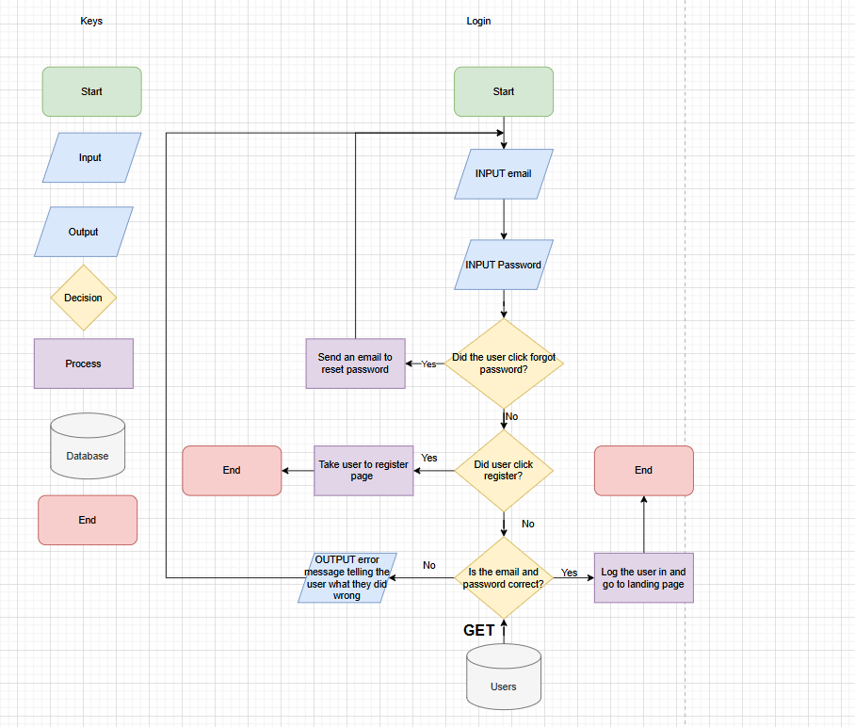

This process begins by entering their email and password, then the system checks whether or not the user has decided to click forgot password, and if they have they receive an email with further instructions, if they click register instead (if they are new users without any accounts), they get taken to the register page instead, and if the existing user comes back and enters their login details, the system checks whether or not if the password and email are correct by getting data from the database, if not they receive an error message telling the user they’ve got their details wrong, going all the way to the beginning where they have to enter the details all over again, but if they’ve entered the details correctly, the user gets redirected to the homepage.

Register Flowchart
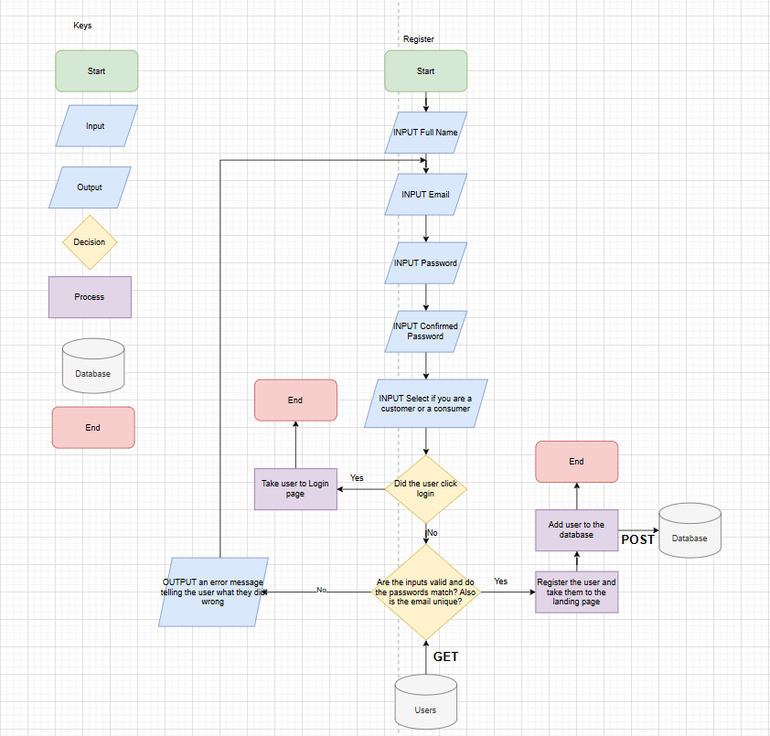
This process begins with the user entering their full name, email, password, confirmed password and selecting whether or not they are a customer or a producer, and once they’ve done that the system checks whether or not they’ve clicked login, and once they have, they are redirected to the login page, however once they’ve clicked register, the system checks if the inputs are valid and if the passwords match, and if the email is unique, if not an error message is outputted, however if the requirements are met, the user gets registered and their information is posted to the database.

Placing an order Flowchart
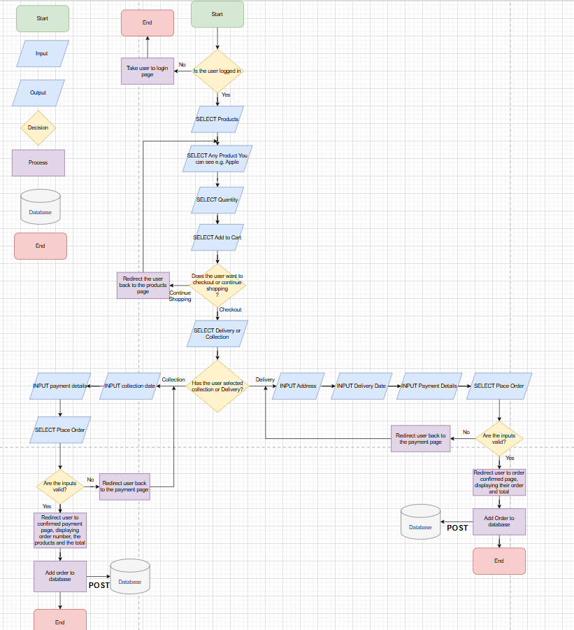
This process begins with the system checking whether or not the user is successfully logged in, if not they are redirected to the login page, if they are, the user then selects the products from the navigation bar, then they would see products listed on the page from other producers, then from there they are able to select it, e.g. Apple, from there they can select the quantity they wish to have, then add to cart, from there the user is given a choice to either checkout or continue shopping to add more products to their cart, and if they choose continue shopping, they are taken back to the products page, where they can find more products to add to cart from producers, if not they are taken to the checkout, where they choose whether for the item to be delivered, or if you wish to collect, if collection is chosen, the user would enter the day they wish to collect, their payment details, then select place order, and from there the system checks if the inputs are valid details, such as checking if the card number is 16 digits long, if the cvv is 3 digits long etc. If it isn’t, the user is redirected back to the payments page, if it Is valid and the money has been successfully processed, the user is taken to a confirmation page, displaying their order number, the items they’ve ordered and the total in the bottom, it is then posted to the database and the process ends from there. However, if delivery was chosen, the user needs to input their address, the date they wish for their items to be delivered, their payment details and from there they select order, and again, the system checks if the payment details are valid credentials, if not they are redirected to the payments page, but if the moneys been processed and valid, the user is again taken to a payment confirmation page, showing their order number, their order and the total, it is then posted to the database from there and the process ends. Their order has been successfully placed.

Producer Managing Stock Flowchart
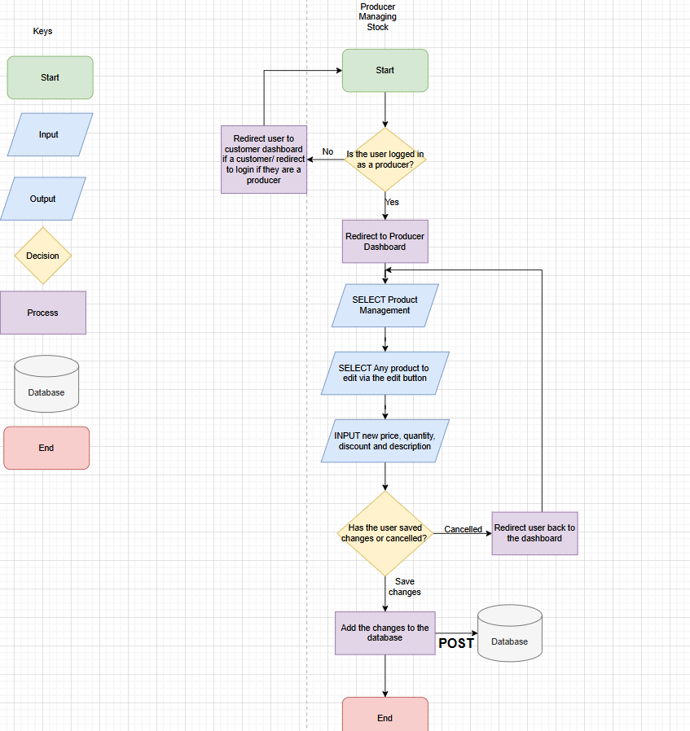
The process begins by checking if the user is logged in a producer, if not they either get redirected to the customer dashboard, or redirected to login if they haven’t logged in at all as a producer (If they are one), if they are they are redirected to the producer dashboard, from there they select product management and they would be able to see the products they are selling, and if they want to manage their stock, they would edit their current listings to either increase their price, add more quantity to it, reduce the price etc. From there they edit the price, or whatever they wish to edit and then the system checks whether or not the user decided to save changes to their product listing or cancel any changes, if the changes are cancelled, they are redirected back to the producer dashboard, however if the changes have been saved, it is posted to the database and from there, the process ends.

Updating Account Details Flowchart
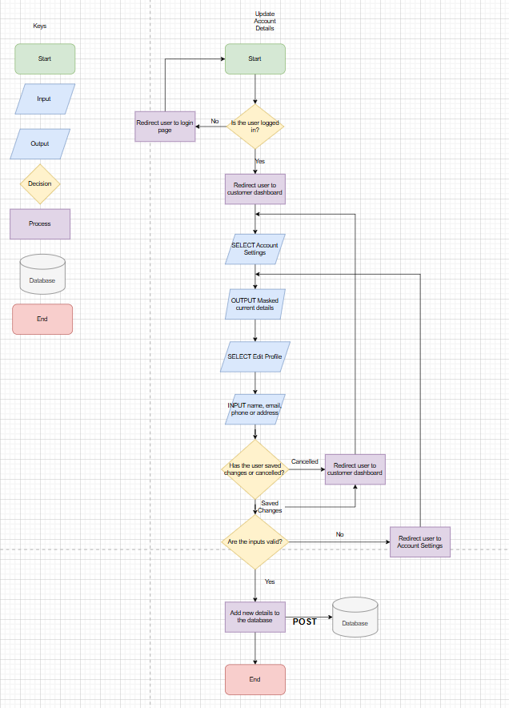
This process begins with checking whether or not the user is logged in, and if not, they are redirected to the login page, if they are logged, in they are taken to the customer dashboard, where they select account settings, outputting the current details but masked so if a third party were looking at the screen they aren’t able to login with your details as asterisks are used. From there they select edit profile, where they can edit their personal information, such as their name, email, phone number and address. And the system checks whether or not if the changes have been saved or cancelled, if it has been cancelled, the system redirects you back to the part where the system shows you the same details that are masked. But if the changes are saved, the system checks if the inputs are valid, if the inputs aren’t valid, the user is redirected to the account settings, but if they are, the new details are posted to the database, and then the process comes to an end.

Test Strategy
Greenfield Local Hub
Date of Test | Component to be Tested | Type of Test to be Carried out | Prerequisites and Dependencies
20/03/2026 | User Register System | White box testing, Black box testing, Functionality testing, Security testing, Integration Testing | The register function must be fully implemented. Migrations and database update must be applied. Controller logic must handle user registration and error handling for incorrect inputs, duplicate accounts and password complexity.  Example Test Data:  Normal:  Name: "John Smith", Email: "test@testmail.com", Password: "Password123?", Confirm Password: "Password123?", Role: "Customer"  Erroneous:  Email: "falseemail" (must contain @ and domain e.g. .com), Password: "111" (too short, no capital, no symbol), Confirm Password: "abc" (does not match original password)  Extreme:  Email: "test@testmail.com", Password: "QwE12?" (exactly 8 characters, minimum length, includes 1 symbol)
20/03/2026 | User Log In System | White box testing, Black box testing, Functionality testing, Security testing, Integration Testing | The login page must be created and the migration and database update must be completed. There must be working controller logic. Testers must test valid/invalid credentials, session management and password encryption.  Example Test Data:  Normal:  Email: "franklin@example.com", Password: "password123"  Erroneous:  Email: "falseemail" (must contain @ and domain), Password: "pass" (too short, missing capital and symbol)  Extreme:  Email: "franklin@example.com", Password: "QwE12?" (minimum valid password)
20/03/2026 | Log Out Function | Black box testing, Functionality testing, Security testing, Session management testing | No test data required. The login system must be fully functional. The logout button must be clearly visible in the navigation bar when a user is logged in. Tester should click logout and verify the session is ended and the user is redirected.
20/03/2026 | Login Button on the Navigation Bar | Black box testing, Functionality Testing, Integration Testing | No test data required. The login page and form should be created and fully functional. The tester should click the button to ensure it loads the login page correctly.
20/03/2026 | Register Button on the Navigation Bar | Black box testing, Functionality Testing, Integration Testing | No test data required. The register page and form should be created and fully functional. The tester should click the button to ensure it loads the register page correctly.
20/03/2026 | Logo on the Navigation Bar | Black box testing, Functionality Testing, Integration Testing | No test data needed. The home page must be created and fully functional. The tester should click the Greenfield Local Hub logo to ensure it takes the user to the home page.
20/03/2026 | Home Link on the Navigation Bar | Black box testing, Functionality Testing, Integration Testing | No test data needed. The navbar should be completely functional and the home page must be created. The tester should click the link to ensure it takes the user to the home page.
20/03/2026 | Products Link on the Navigation Bar | Black box testing, Functionality Testing, Integration Testing | No test data needed. The navbar should be completely functional and the products page must be created. The tester should click the link to ensure it takes the user to the products page.
20/03/2026 | Producers Link on the Navigation Bar | Black box testing, Functionality Testing, Integration Testing | No test data needed. The navbar should be completely functional and the producers page must be created. The tester should click the link to ensure it takes the user to the producers page.
20/03/2026 | Shopping Cart Icon on the Navigation Bar | Black box testing, Functionality Testing, Integration Testing | No test data needed. The navbar must be fully functional and the cart page must be created. The user must be logged in as a customer. The tester should click the cart icon and verify it loads the correct cart page and displays the badge count correctly.
20/03/2026 | Accessibility Settings Button on the Navigation Bar | Black box testing, Functionality Testing | No test data needed. The navbar must be fully functional and the accessibility context must be implemented. The tester should click the settings icon to verify the accessibility dropdown opens and displays Dark Mode, Font Size and High Contrast options.
20/03/2026 | Dark Mode Toggle | Black box testing, Functionality Testing | No test data needed. The accessibility settings must be fully implemented and the AccessibilityContext must be created. The tester should click the Dark toggle and verify the site switches to a dark colour scheme across all pages.
20/03/2026 | Font Size Selector (Small/Medium/Large) | Black box testing, Functionality Testing | No test data needed. The accessibility settings must be fully implemented. The tester should click each font size option (Small, Medium, Large) and verify the text size changes across the site accordingly.
20/03/2026 | High Contrast Toggle | Black box testing, Functionality Testing | No test data needed. The accessibility settings must be fully implemented. The tester should toggle high contrast on and verify that colour contrast increases across the site for improved readability.
20/03/2026 | Shop Now Button on the Home Page Hero Section | Black box testing, Functionality Testing, Integration Testing | No test data required. The home page must be fully functional and the products page must be created. The tester should click the button to ensure it takes the user to the products page.
20/03/2026 | Meet Our Producers Button on the Home Page Hero Section | Black box testing, Functionality Testing, Integration Testing | No test data required. The home page and producers page must both be created and fully functional. The tester should click the button to ensure it takes the user to the producers page.
20/03/2026 | Special Offers Product Cards on the Home Page | Black box testing, Functionality Testing, Integration Testing | No test data required. The home page and product detail pages must be created. Mock data must contain discounted products. The tester should click a product card to ensure it navigates to the correct product detail page.
20/03/2026 | Create Your Account Button on the Home Page CTA Section | Black box testing, Functionality Testing, Integration Testing | No test data required. The home page and register page must be created and fully functional. The tester should click the button to verify it takes the user to the register page.
20/03/2026 | Search Bar on the Products Page | Black box testing, White box testing, Functionality Testing | No test data required. The products page must be created and all products must be loaded from the data source. The tester should type a product name into the search bar and verify the product grid filters correctly in real time.  Example Test Data:  Normal: "Carrots" (should return Organic Carrots)  Erroneous: "zzzzz" (should return 0 results)  Extreme: "a" (single character, should return all products containing the letter a)
20/03/2026 | Category Filter Dropdown on the Products Page | Black box testing, Functionality Testing | No test data required. The products page must be created. The tester should select each category (Vegetables, Dairy, Fruit, Pantry, Eggs) and verify the grid only shows products from that category.
20/03/2026 | Producer Filter Dropdown on the Products Page | Black box testing, Functionality Testing | No test data required. The products page must be created with all producers in the dropdown. The tester should select each producer and verify only their products appear in the grid.
20/03/2026 | Offers Only Checkbox on the Products Page | Black box testing, Functionality Testing | No test data required. The products page must be created and there must be products with discounts in the data. The tester should check the box and verify only discounted products with badges are shown.
20/03/2026 | Product Card on the Products Page | Black box testing, Functionality Testing, Integration Testing | No test data required. The products page and product detail page must both be created. The tester should click a product card and verify it navigates to the correct product detail page showing the matching product name, price and description.
20/03/2026 | Add to Cart Button on the Product Detail Page | Black box testing, White box testing, Functionality Testing, Integration Testing | The product detail page and cart functionality must be created. A customer user must be logged in. The tester should select a quantity and click Add to Cart, then navigate to the cart page to verify the item appears with the correct quantity and price.
20/03/2026 | Quantity +/- Controls on the Product Detail Page | Black box testing, Functionality Testing | The product detail page must be created. The tester should click the + and - buttons and verify the quantity changes correctly and does not go below 1 or above the available stock level.
20/03/2026 | View Full Profile Button on the Product Detail Page | Black box testing, Functionality Testing, Integration Testing | The product detail page and producer detail page must be created. The tester should click the button and verify it navigates to the correct producer profile page.
20/03/2026 | Producer Card on the Producers Page | Black box testing, Functionality Testing, Integration Testing | The producers page and producer detail pages must be created. The tester should click a producer card and verify it navigates to the correct producer detail page showing the correct name, location, about us and farming methods.
20/03/2026 | Product Cards on the Producer Detail Page | Black box testing, Functionality Testing, Integration Testing | The producer detail page and product detail pages must be created. The tester should click a product card on the producer detail page and verify it navigates to the correct product detail page.
20/03/2026 | View All Products Button on the Producer Detail Page | Black box testing, Functionality Testing, Integration Testing | The producer detail page and products page must be created. The tester should click the button and verify it navigates to the main products page.
20/03/2026 | Quantity +/- Controls on the Cart Page | Black box testing, Functionality Testing | The cart page must be created and cart functionality must be implemented. There must be at least one item in the cart. The tester should click + and - on a cart item and verify the quantity and line total update correctly.
20/03/2026 | Remove Button on the Cart Page | Black box testing, Functionality Testing | The cart page must be created and cart functionality must be implemented. There must be at least one item in the cart. The tester should click Remove and verify the item is removed from the cart and the order summary total updates correctly.
20/03/2026 | Proceed to Checkout Button on the Cart Page | Black box testing, Functionality Testing, Integration Testing | The cart page and checkout page must be created. There must be at least one item in the cart. The tester should click the button and verify it navigates to the checkout page.
20/03/2026 | Continue Shopping Link on the Cart Page | Black box testing, Functionality Testing, Integration Testing | The cart page and products page must both be created. The tester should click the link and verify it takes the user back to the products page.
20/03/2026 | Collection Option on the Checkout Page | Black box testing, Functionality Testing | The checkout page must be created and the delivery method toggle must be implemented. The tester should select Collection and verify the delivery address field is hidden, the delivery fee shows £0.00 and the date label changes to Collection Date.
20/03/2026 | Home Delivery Option on the Checkout Page | Black box testing, Functionality Testing | The checkout page must be created and the delivery method toggle must be implemented. The tester should select Home Delivery and verify the delivery address field appears, the delivery fee shows £3.50 and the total updates accordingly.
20/03/2026 | Delivery Address Field on the Checkout Page | Black box testing, Functionality Testing | The checkout page must be created and Home Delivery must be selected. The tester should leave the field blank and attempt to place an order to verify validation prevents submission without an address.
20/03/2026 | Scheduled Date Picker on the Checkout Page | Black box testing, White box testing, Functionality Testing | The checkout page must be created. The tester should attempt to select a past date and verify it is blocked. They should then select a future date and verify it is accepted.  Example Test Data:  Normal: A valid future date e.g. 25/04/2025  Erroneous: A past date e.g. 01/01/2020 (should be blocked)  Extreme: Today's date (should be blocked as the minimum is tomorrow)
20/03/2026 | Payment Details Form on the Checkout Page | Black box testing, White box testing, Functionality Testing, Security Testing | The checkout page must be created and the payment form must be implemented. The tester should submit the form with missing or invalid fields and verify appropriate error handling occurs.  Example Test Data:  Normal:  Cardholder Name: "John Smith", Card Number: "4111111111111111", Expiry: "12/26", CVV: "123"  Erroneous:  Card Number: "abc" (must be numeric), CVV: "ab" (must be 3 digits), Expiry: "00/00" (invalid date)  Extreme:  Card Number with exactly 16 digits (boundary)
20/03/2026 | Place Order Button on the Checkout Page | Black box testing, White box testing, Functionality Testing, Integration Testing | The checkout page, order confirmation page and order context must all be created and functional. A logged in customer must have items in their cart. The tester should complete all fields correctly and click Place Order, then verify they are redirected to the order confirmation page with the correct order details displayed.
20/03/2026 | View Order History Button on the Order Confirmation Page | Black box testing, Functionality Testing, Integration Testing | The order confirmation page and customer dashboard must be created. The tester should click the button and verify it navigates to the customer dashboard orders tab showing the newly placed order.
20/03/2026 | Continue Shopping Button on the Order Confirmation Page | Black box testing, Functionality Testing, Integration Testing | The order confirmation page and products page must be created. The tester should click the button and verify it navigates back to the products page.
20/03/2026 | Order History Tab on the Customer Dashboard | Black box testing, Functionality Testing, Integration Testing | The customer dashboard must be created and a customer must be logged in with at least one order placed. The tester should click the Order History tab and verify all orders are displayed with the correct status, date, items and total.
20/03/2026 | Account Settings Tab on the Customer Dashboard | Black box testing, Functionality Testing | The customer dashboard must be created and a customer must be logged in. The tester should click the Account Settings tab and verify masked personal details (email, phone, password) are displayed correctly.
20/03/2026 | Edit Profile Button on the Customer Dashboard | Black box testing, White box testing, Functionality Testing, Integration Testing | The customer dashboard and account update functionality must be created. The tester should click Edit Profile and update the name, phone and address fields, then save and verify the changes are reflected.  Example Test Data:  Normal:  Name: "Franklin Smith", Phone: "07700900000", Address: "123 Main Street, Greenfield"  Erroneous:  Phone: "notanumber" (must be valid numeric format)  Extreme:  Name with maximum allowed characters
20/03/2026 | Cancel Button on the Customer Dashboard Edit Form | Black box testing, Functionality Testing | The customer dashboard edit form must be created. The tester should click Edit Profile, make changes to the fields and then click Cancel and verify the original data is restored and no changes were saved.
20/03/2026 | Product Management Tab on the Producer Dashboard | Black box testing, Functionality Testing, Integration Testing | The producer dashboard must be created and a producer must be logged in. The tester should click the Product Management tab and verify all of their products are listed with the correct name, price, stock and discount badge where applicable.
20/03/2026 | Edit Button on the Producer Dashboard Product List | Black box testing, White box testing, Functionality Testing, Integration Testing | The producer dashboard must be created and a producer must be logged in. The tester should click Edit on a product and verify the inline edit form opens with the current price, stock, discount and description pre-filled.  Example Test Data:  Normal:  Price: "3.50", Stock: "40", Discount: "10", Description: "Updated description"  Erroneous:  Price: "free" (must be a number greater than 0), Stock: "-5" (must be 0 or greater)  Extreme:  Discount: "100" (boundary value, 100% off)
20/03/2026 | Save Button on the Producer Dashboard Edit Form | Black box testing, Functionality Testing, Integration Testing | The producer dashboard edit form must be created. The tester should edit a product and click Save, then verify the updated values are reflected in the product list and on the products page.
20/03/2026 | Cancel Button on the Producer Dashboard Edit Form | Black box testing, Functionality Testing | The producer dashboard edit form must be created. The tester should click Edit, change values and then click Cancel and verify the original values are restored and no changes were saved.
20/03/2026 | Orders Tab on the Producer Dashboard | Black box testing, Functionality Testing, Integration Testing | The producer dashboard must be created, a producer must be logged in and there must be at least one order containing their products. The tester should click the Orders tab and verify orders are listed with the correct items, quantities, totals and current status.
20/03/2026 | Order Status Dropdown on the Producer Dashboard | Black box testing, Functionality Testing, Integration Testing | The producer dashboard orders tab must be created and there must be at least one order. The tester should change the status dropdown from Processing to Scheduled, then Ready, then Delivered and verify each change is saved and reflected on the customer dashboard order history.
20/03/2026 | Products Link on the Footer | Black box testing, Functionality Testing, Integration Testing | No test data needed. The footer must be functional and the products page must be created. The tester should click the link and verify it navigates to the products page.
20/03/2026 | Producers Link on the Footer | Black box testing, Functionality Testing, Integration Testing | No test data needed. The footer must be functional and the producers page must be created. The tester should click the link and verify it navigates to the producers page.
20/03/2026 | Privacy Policy Link on the Footer | Black box testing, Functionality Testing, Integration Testing | No test data needed. The footer must be functional and the privacy policy page must be created. The tester should click the link and verify it navigates to the privacy policy page and all sections are displayed correctly.
20/03/2026 | Register Link on the Footer | Black box testing, Functionality Testing, Integration Testing | No test data needed. The footer must be functional and the register page must be created. The tester should click the link and verify it navigates to the register page.
20/03/2026 | Cookie Consent Banner | Black box testing, Functionality Testing | No test data needed. The cookie consent banner must have been implemented. The tester should visit the site for the first time and verify the banner appears at the bottom of the screen.
20/03/2026 | Accept Cookies Button on the Cookie Banner | Black box testing, White box testing, Functionality Testing, Integration Testing | No test data needed. The cookie consent banner must be implemented and functional. The tester should click Accept Cookies and verify the banner disappears and does not reappear on subsequent visits.
20/03/2026 | Reject Button on the Cookie Banner | Black box testing, White box testing, Functionality Testing, Integration Testing | No test data needed. The cookie consent banner must be implemented and functional. The tester should click Reject and verify the banner disappears and the site continues to function correctly.
20/03/2026 | Privacy Policy Page Content | Black box testing, Functionality Testing | No test data needed. The privacy policy page must be created with all sections. The tester should navigate to the page and verify all 11 sections are displayed correctly including Introduction, Information We Collect, Your Rights Under UK GDPR and Contact Us.

